SOCIAL MEDIA ANALYTICS
5. Social Information Filtering
5.1 Social Information Filtering - Social Sharing and filtering , Automated Recommendation systems, Traditional Vs social Recommendation Systems Understanding Social Media and Business Alignment, Social Media KPI, Formulating a Social Media Strategy, Managing Social Media Risks
PAST QUESTIONS:
- Explain the four steps in social media risk management. (M24)
- What are different social media KPIs. (M24)
- Compare Traditional recommendation system and Social Recommendation System. (M24)
- Collaborative Filtering for recommendation. (M24)
- Describe Automated Recommendation Systems and compare Traditional Recommendation Systems with Social Recommendation Systems. (M25)
- Discuss the key steps involved in Formulating a Social Media Strategy and highlight how organizations can Manage Social Media Risks effectively. (M25)
- Explain the importance of Understanding Social Media and Business Alignment, and describe key Social Media KPIs used to measure performance. (M25)

NOTES:

Social Media KPIs :-
Social media KPIs (Key Performance Indicators) are specific, measurable metrics—such as engagement rate, conversion rate, reach, and follower growth—that align social media activities with business goals, such as increasing brand awareness or ROI. They allow marketers to assess if their strategy is working and to make data-driven improvements, generally tracked via dashboards for better insights.
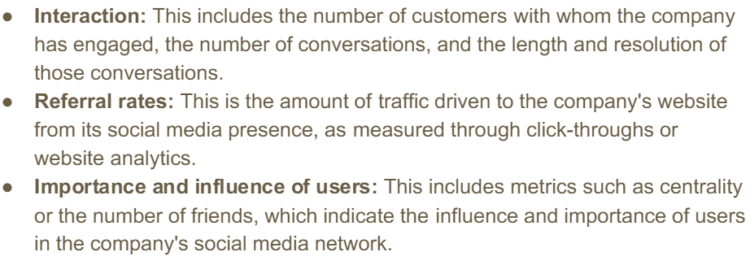
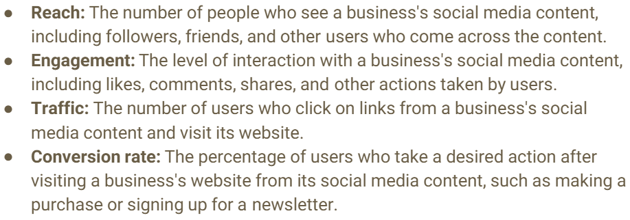
*Traditional vs Social Recommendation systems :-
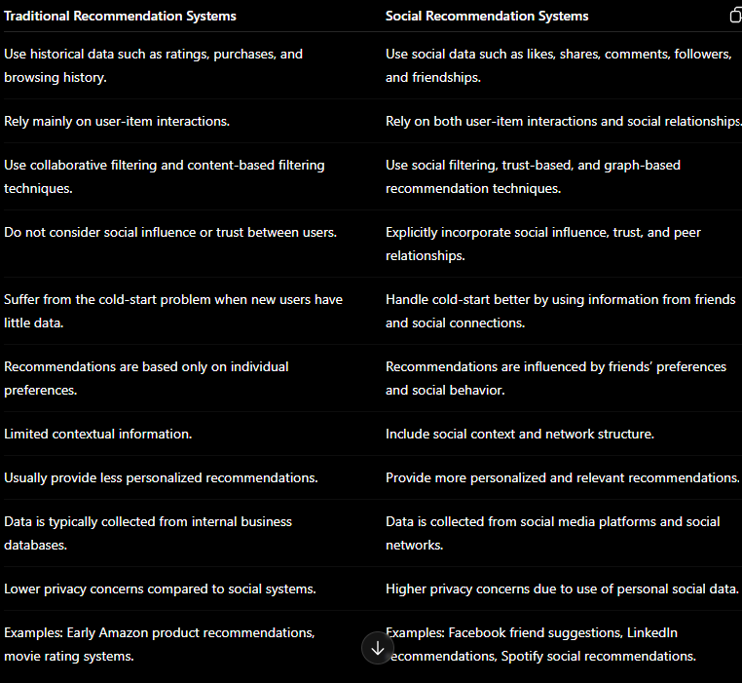
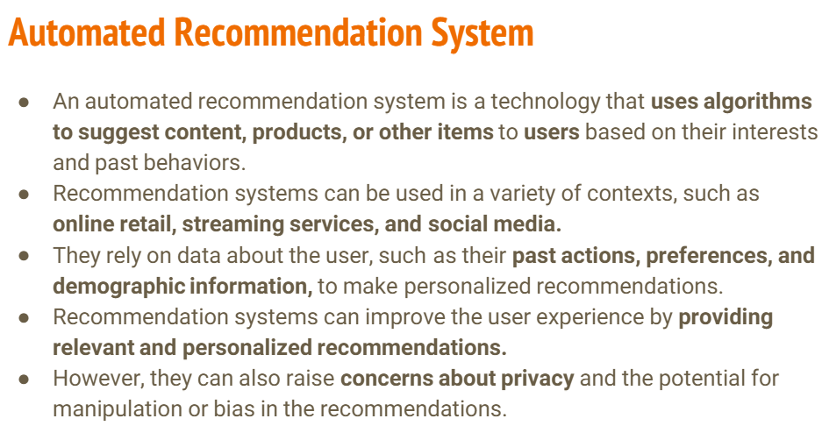
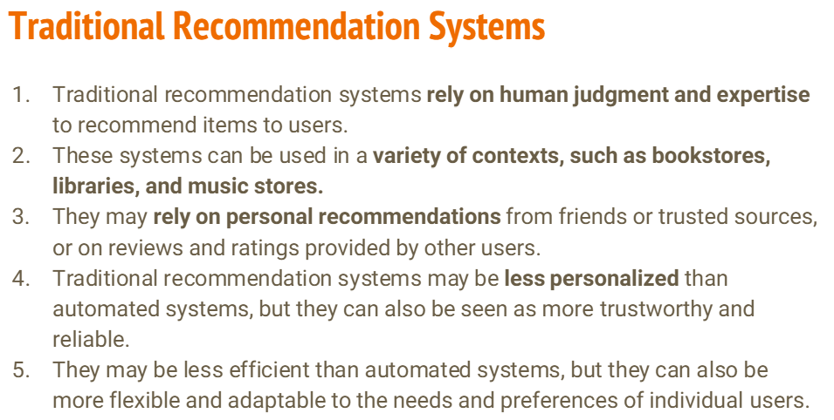
Explain the four steps in social media risk management :-
